Wichtige Informationen NeoPixel (https://learn.adafruit.com/adafruit-neopixel-uberguide?view=all)

* NeoPixels powered by 5v ideally require a 5V data signal. If using a 3.3V microcontroller, it’s wise to use a logic level shifter such as a [74AHCT125](https://www.adafruit.com/product/1787) or [74HCT245](https://www.adafruit.com/products/1779). If you are powering your NeoPixels with 3.7v directly from a LiPoly cell, a 3.3v data signal is OK. See the “Logic Level Shifting” page for further information.
* If the board doesn’t have a pin #6, you’ll need to modify the example code to change the pin number.
* “DOUT” or “DO” (data out) at the end of a NeoPixel chain can be left unconnected. If adding more pixels later, data-out from one chain connects to data-in of the next.
* 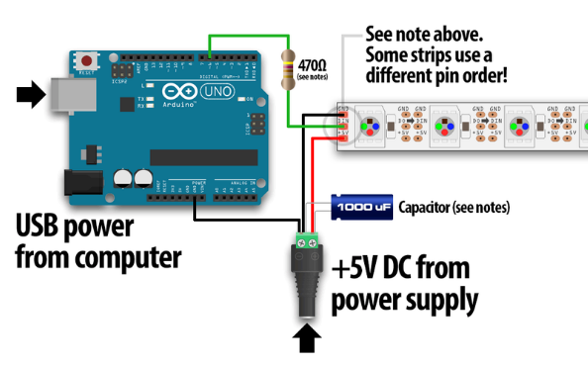
* For other Arduino boards with a separate +5V DC power supply for the NeoPixels: connect the +5V input on the strip to the + (positive) terminal on the power supply (don’t connect to the Arduino), DIN to digital pin 6 on the Arduino, and – (minus or GND) on the strip must connect to both the minus (–) terminal on the DC supply and a GND pin on the Arduino (there are usually several — any will do).
* When using a DC power supply, or an especially large battery, we recommend **adding a large capacitor** (100 to 1000 µF, 6.3V or higher) across the + and – terminals. This prevents the initial onrush of current from damaging the pixels. See the photo on the next page for an example.
* Adding a ~470 ohm resistor between your microcontroller's data pin and the data input on the NeoPixels can help prevent spikes on the data line that can damage your first pixel. Please add one between your micro and NeoPixels! Our NeoPixel rings already have this resistor on there
* It’s impossible to estimate a single number for all circumstances, but we’ve been using 1/3 this (20 mA per pixel) as a gross rule of thumb with no ill effects. But if you know for a fact that you need every pixel on at maximum brightness, use the full 60 mA figure.